1. Use Case Diagram in UML may include:
2. The Use Case Diagram in UML ______?
3. The good Use Case Diagram in UML is _____
4. The good Use Case Diagram in UML is not ______
5. An actor in UML is _____
6. The use case description properties are:
7. A Use case diagram in UML ______
8. Actor-use case relationships with arrowheads show____
9. Choose the Google algorithm:
10. Founders of the Yandex search engine are:
11. The Yandex search engine was created in/on _____
12. The Yahoo search engine was created by ____
13. The Yahoo search engine was created in/on _____
14. Founders of the Google search engine are:

The Google search engine was created on/in ______

1. Founder(s) of the Rambler search engine is/are:
2. The Rambler search engine was created in/on _____
3. Founder(s) of the Bing search engine is/are___
4. The Bing search engine was created on/in ____
5. The reason(s) why the Use-Case modeling is useful:
6. An actor represents ____
7. Which of these describes use case diagrams?
8. You should add a row using SQL in a database with the command:
9. To define what columns should be displayed in an SQL SELECT statement:
10. The SQL statement that queries or reads data from a table is ________
11. SQL is
12. “ADO” means an _____
13. ADO has been developed by_______
14. A student’s ability to observe and understand the world around, ability to choose aims, make decisions is _______
15. A student’s ability to learns to perform the role of citizen, observer, elector is _______
16. A student’s ability to master physical, spiritual, and intellectual self-development approaches, emotional self-regulation and self-support is _______
17. A student’s ability to become proficient in creative skills of productive activity, knowledge acquisition from reality by the use of cognition methods is ______
18. A student’s ability to independently search, analyze and select required information, organize, transform, save and transfer it is _____.
19. The range of subjects in which a student should be thoroughly enlightened, have a deep knowledge and activity experience is called____.
20. An information source for a researcher that objectively exists in theory and practice is called a(n)________
21. Part of the real world for which a database is created to automate the data management process is called a(n)_______
22. The Information System used to identify errors is the _______
23. A detailed study of the Information System for each item in quality project planning is called ____
24. Complexity, divisibility, integrity, structure is/ are called ________
25. Planning, accounting, analysis, control, regulation are referred to as _____
26. Student’s ability to gain the necessary information in the adjusted time interval is referred to as
27. Construction of a computer model is based on _____ the concrete nature of a phenomenon or the analyzed object-original
28. A set of principles and approaches to modeling logical organization methods and modeling tools is referred to as ___
29. The basic unit of information stored in the database subject area is called a/n_____
30. A sequence of instructions, written to perform a specified task with a computer is called (a/n) _______
31. A program or a logically related set of programs that allows you to create programs and documentation provided with the software is called____
32. A set of elements associated with each other and with the environment in an orderly manner, selected for a specific purpose and to perform specified functions, aimed at obtaining a specific beneficial result is referred to as a/n ________
33. A modern IS (information system) is incomprehensible without the use of:
34. The source document for the development of information systems, standards or conduct of scientific research is called a/n______
35. Necessity and indispensability of the IS in solving a specific current problem is addressed in:
36. A system of views and ideas, which reveal the concept and the global goal-oriented perspective of the future is indicated in______
37. The basic organization of the system embodied in its components (significant decisions set of structural elements and their interfaces), and their relationships with each other and with the environment behavior, as well as the principles governing the design and development of IS (information system) is referred to as (a)_________
38. The part of IS focusing on the characteristics needed by the user is referred to as IS ______
39. Commitment to stable equilibrium state, which implies adaptation of software system parameters to changing parameters of the environment is referred to as _____
40. A set of means by which the user communicates with computer or appliances, or other complex equipment is referred to as (a/n)_____
41. The diagram which shows static parts of a system is called a ______
42. A _____ works with the dynamic parts of a system
43. This model is called a/n ______

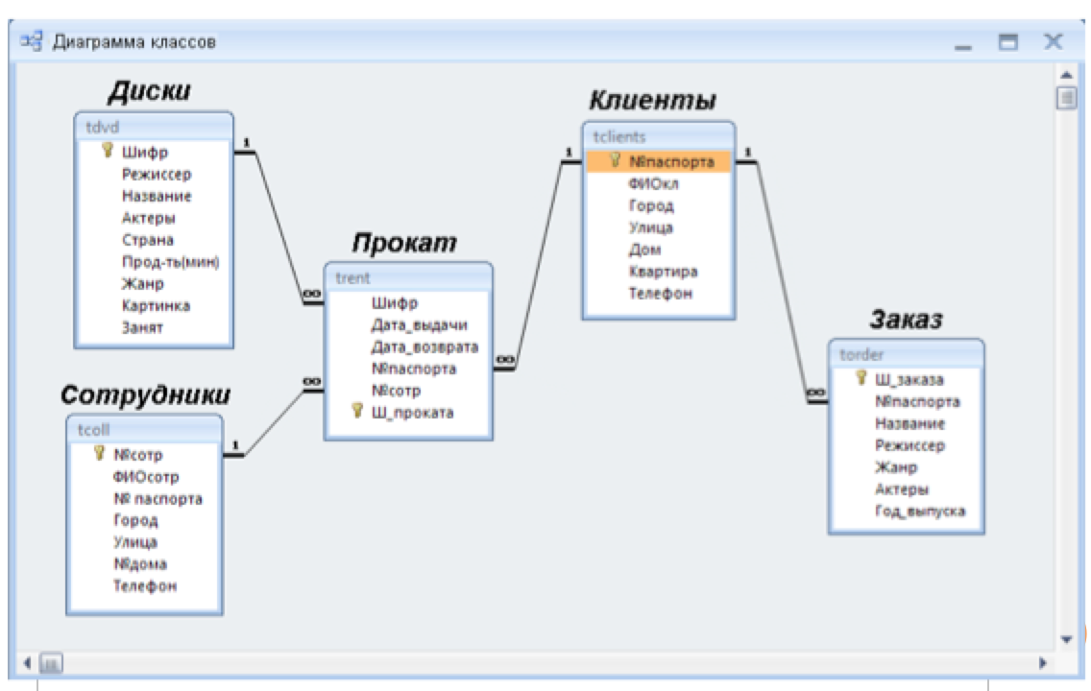

1. This model is called a/n ______

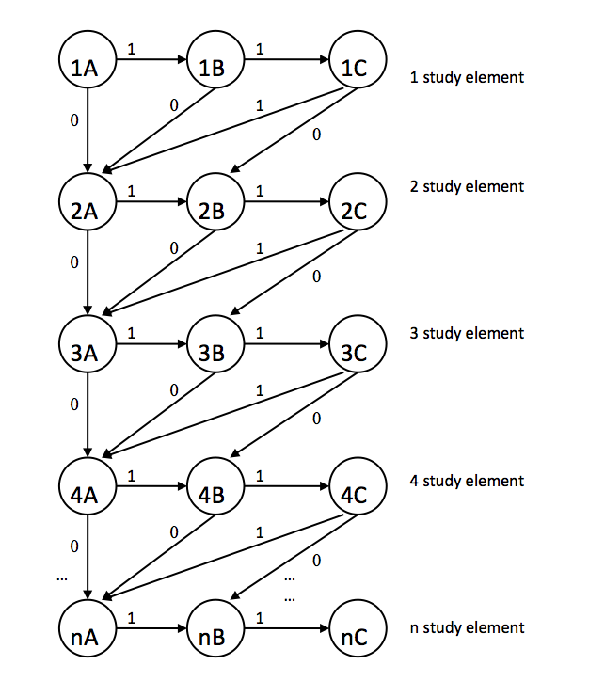

1. This model is called a/n ______

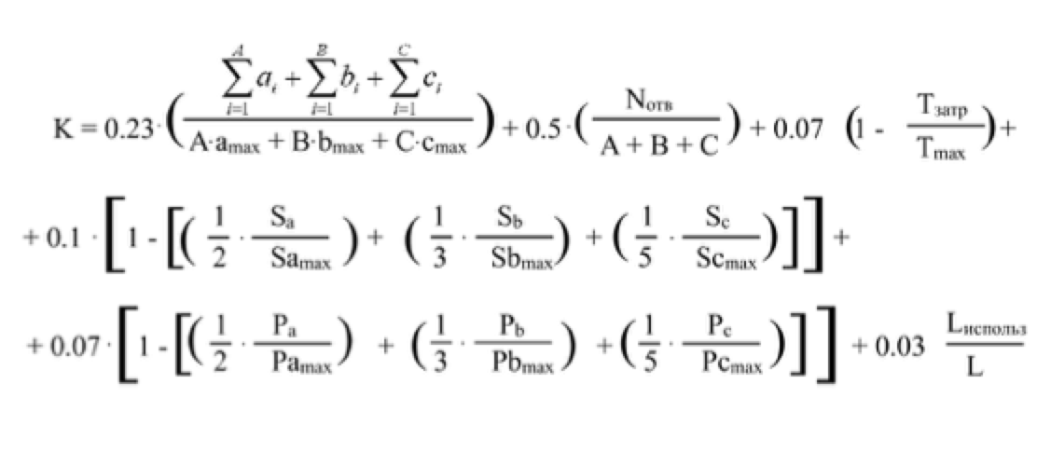

1. This UML is called a/n ______



1. This UML is called a/n ____:



1. This UML is called a/n ____



1. This UML is called a/n ____
2. An information system's architecture is ______
3. Information systems supporting the business functions that reach out to customers (or constituents) are known as:
4. Information system builders and designers tend to focus on:
5. Business Knowledge is derived from:
6. Which of the following is a system owner interested in?
7. Historically, most information systems were _______- centered
8. Which of these is a database language:
9. Business process requirements are frequently defined in terms of :
10. A unifying framework in which various people with different perspectives can organize and view the fundamental building blocks of information systems is known as a(n):
11. Cross-functional information systems are:
12. Representation of users' data in terms of entities, attributes, relationships and rules is known as:
13. The technical design of business processes to be automated or supported by computer programs to be written by systems builders is known as (a/n) ____
14. Language-based, machine readable representations of what a software process is supposed to do, or how a software process is supposed to accomplish its task is known as:
15. A layer of utility software that sits between the application software and systems software to transparently integrate differing technologies for their interoperation is called a(n):
16. XML (eXtensible Markup Language) is a technology used for:
17. Determine the type of system composed of many components interacting with each other:
18. Implementation of new connections between elements in a complex system leads to _____
19. The ability of a system to adjust itself efficiently and fast to changing circumstances is called its____
20. The IS property concerning its impact on the mass consciousness is called its____
21. Type of content that exists in the form of digital data, also known as digital media, stored in either digital or analog formats is called ____
22. Property of the system showing the possibility to operate in the event of failure of one or more components is called _____
23. Management of information and communication technology in pursuit of a competitive advantage over an opponent is referred to as ____
24. A wide and heterogeneous set of manual or computer-assisted techniques for contextualized interpretations of documents produced by communication processes, having as ultimate goal the production of valid and trustworthy inferences is referred to as _____
25. Type of information system, usually available on a standalone personal computer (without network access) is called ___
26. Choose the type of systems focused on the collective use of information by members of the working group and based on the local area network:
27. The category of business-management IS, typically a suite of integrated applications that an organization can use to collect, store, manage and interpret data from many business activities is called _____
28. In a database system, ____ is responsible for providing data consistency
29. The database management system acting as an interface between two components of an enterprise-class database system is called ____
30. An app in which only one user accesses the database at a given time is an example of a(n) ________
31. An online commercial site such as [lamoda.kz](http://lamoda.kz/) is an example of a(n) ________
32. SQL stands for _______
33. A database containing a description of its own structure is called ________
34. A(n) ______ is used to keep track of things
35. An Enterprise Resource Planning application is an example of a(n) ________
36. The SQL script used to remove rows from a 'CUSTOMER' table is :
37. The command to eliminate a table from a database is:
38. Only the ______ gives access to a table and permission to work with it
39. The correct order of keywords for SQL SELECT statements is:
40. Find the SQL statement below that is equal to the following: SELECT NAME FROM CUSTOMER WHERE STATE = 'VA'
41. Planning, accounting, analysis, control, regulation are referred to as _____
42. Student’s ability to gain the necessary information in the adjusted time interval is referred to as
43. Construction of a computer model is based on _____ the concrete nature of a phenomenon or the analyzed object-original
44. A set of principles and approaches to modeling logical organization methods and modeling tools is referred to as ___
45. The basic unit of information stored in the database subject area is called a/n_____
46. A sequence of instructions, written to perform a specified task with a computer is called (a/n) _______
47. Founders of the Google search engine are:

The Google search engine was created on/in ______

1. Founder(s) of the Rambler search engine is/are:
2. The Rambler search engine was created in/on _____
3. Founder(s) of the Bing search engine is/are___
4. Type of information system, usually available on a standalone personal computer (without network access) is called ___
5. Choose the type of systems focused on the collective use of information by members of the working group and based on the local area network:
6. The category of business-management IS, typically a suite of integrated applications that an organization can use to collect, store, manage and interpret data from many business activities is called _____
7. In a database system, ____ is responsible for providing data consistency
8. The database management system acting as an interface between two components of an enterprise-class database system is called ____
9. To define what columns should be displayed in an SQL SELECT statement: